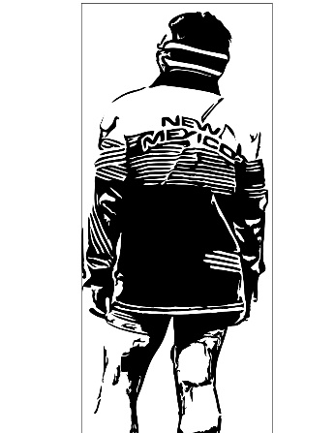
2022 AAU Spartan Wrestling Team Registration Form

Wrestlers Name: ______________Estimated WT.: _________

DOB: ____________________Grade: ________

Parent/Legal Guardian:______________________________

Address______________________________ City______________________

Phone_________________ Shirt Size:___________

Email:_________________________________________ make legible

Parent Signature__________________________ Date__________________

___________TO BE COMPLETED BY SWA_____________
__________________________________________
AAU #_______________________
AAU card $14
Team Fee $21

